Prepare rules for the all the data sets
1) Try different values of support and confidence. Observe the change in number of rules for different support,confidence values
2) Change the minimum length in apriori algorithm
3) Visulize the obtained rules using different plots
BOOKS DATASET:-
In books dataset,i tried minimum length as 0.002 then formed 1673 support values,also lift has 93394 dataframes.In without redudancy 1661 dataframes are formed.
And I tried many small values in support.
In my analysis,I give minimum length as 0.03 then formed 181 support values,also lift has 1676 dataframes formed.In without redudancy 170 dataframes are formed.
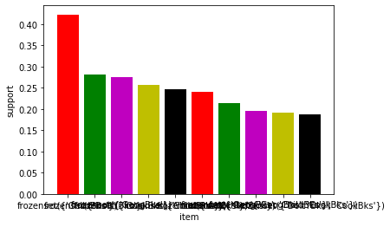
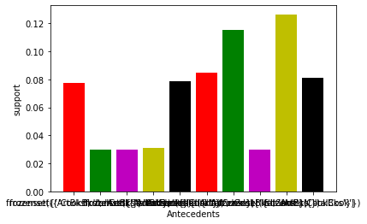

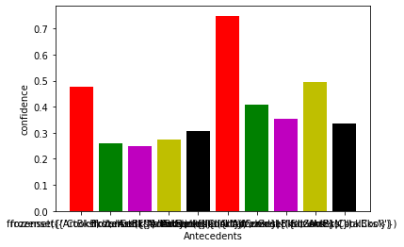
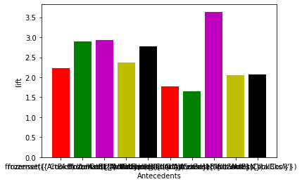

MY_MOVIES DATASET:-

In movies dataset,there have minimum number of datas.
So i will take minimum support value as 0.1 then formed 53 support values,also lift has formed 238 dataframes.In without redudancy 39 dataframes formed.
If i take support value as 0.5,they formed mimimum number of dataframes.In without redudancy they formed one or two dataframes.so we doesnot analyse the datasets properly.

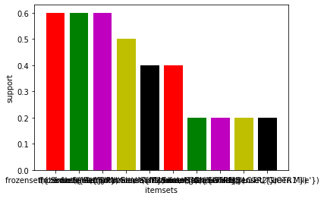
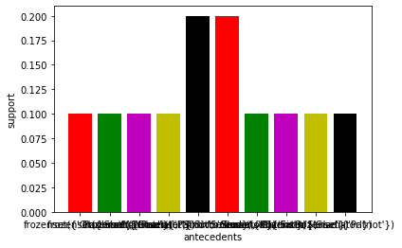

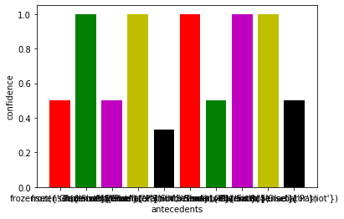
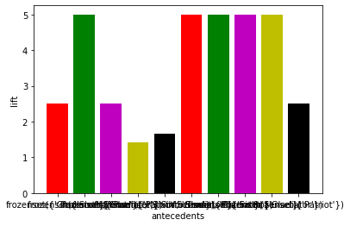

Groceries dataset:-
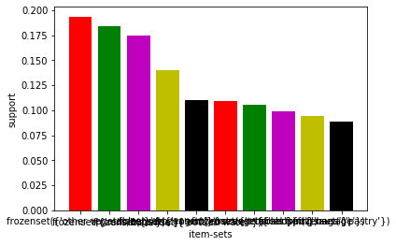
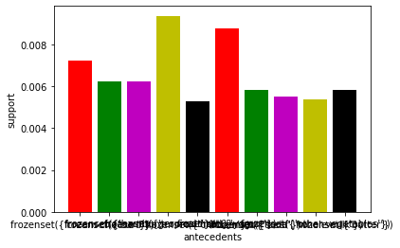
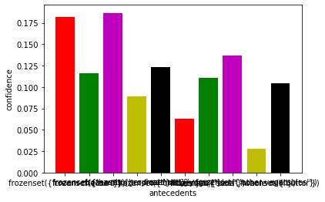
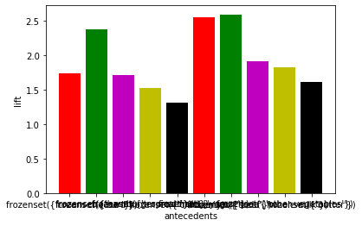
In groceries dataset is the larger dataset.I will take minimum support as 0.005 then formed 1001 support values,also lift has formed 2868 dataframes.In without redudancy 842 dataframes formed.If i take 0.5 as support value,they formed minimum support values,so we cant analyse the datasets properly.

